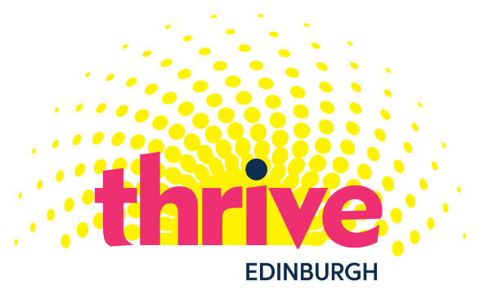

Edinburgh Thrive Arts Programme 2021
Information for Small Grants Applicants

Purpose
Edinburgh Thrive Arts Programme is a key component of the city’s mental health and wellbeing strategy and established to ensure a year-long focus on the power of the arts to challenge stigma, promote participation and social connections, and a strong focus on public and participatory art which functions both as an expression of community resilience and also as a vehicle for personal and community healing.

The purpose of the small grants award programme is to support a range of events and activities throughout the year including:

Scottish Mental Health Arts Festival (SMHAF) 2021
The theme for this year’s SMHAF is Normality?. The festival will run from Monday 3 to Sunday 23 May 2021. Events and activities which are part of SMHAF will be included in their online programme. Please note that it is unlikely that there will be a printed programme this year. https://www.mhfestival.com/

Mental Health Awareness Week
Mental Health Awareness Week will take place from 10-16 May 2021 and the theme this year is Nature and the Environment: https://www.mentalhealth.org.uk/campaigns/mental-health-awareness-week

Edinburgh ThriveFest
ThriveFest #2 will take place on 10th October as part of World Mental Health Awareness Day.
https://www.edinburghthrive.com/

Out of Sight Out of Mind
This yearly exhibition takes place in October. Please note there will be a separate grant process for Out of Sight Out of Mind. https://www.outofsightoutofmind.scot/

Grants
- Individuals, constituted groups and organisations can apply for up to £500 for costs towards art activities and events which are part of either or both programmes.
- Applications should be submitted by midday on Monday 22 February 2021 by email to pam@capsadvocacy.org

- Grants are available for:
- Artist/facilitator fees
- Volunteer costs
- Materials
- Publicity
- Venue hire
- Refreshments
- Other costs of delivering the activity/event

- Please detail costs as clearly as possible in applications
- Individuals can apply for fees for their services. However, they should be registered self-employed if applicable.
- Grant awardees are expected to comply with health and safety regulations in respect of running events.
- The grant can contribute to a larger activity/event. This should be specified in the application
- You will be notified of the outcome of your application on Monday 1st March 2021

This small grants programme is funded by Edinburgh Health and Social Care Partnership. It is administered by CAPS Independent Advocacy. CAPS Independent Advocacy is a Scottish Charitable Incorporated Organisation. Scottish Charity number SC021772.

COVID
Everyone involved understands that there may be changes or delays to planned activities and events due to COVID 19 restrictions. Grant awardees are asked to let others know about any relevant changes. This might be grant administrators CAPS Independent Advocacy, the Edinburgh Thrive team, SMHAF programmers, the people taking part in activities/events or anyone else you are working with.

Important payment information
If your application is successful, payment will be made within sixty days after we receive your bank account details. Payment will be by BACS payment only and no cash or cheque payments can be made.

Grants inquiries
Please get in touch with any questions or to discuss an application, by email pam@capsadvocacy.org or by phone 07989 402634.

Previously known as “A Sense for Belonging Arts” Programme

