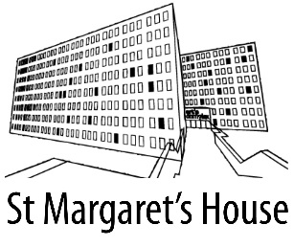
Studio Request Form/Waiting List Sign Up

TAKEN BY : ___________________________________ TODAYS DATE______________________

ABOUT THE ENQUIRY
Please circle
INDIVIDUAL ARTIST | GROUP OF ARTISTS LOOKING TO SHARE | CHARITY / COMMUNITY ORGANISATION | NEW SME STARTUP | OTHER

Size of Studio Wanted (number of windows and approximate floor space ft² )
Please Circle
1 Window (100 ft²) - £120 p.c.m. 2 Windows (200 ft²) £180 p.c.m 3 Windows* or more (300 ft²) £270*

EARLIEST START DATE:

EMAIL ADDRESS:

FULL NAME:

MOBILE No:

FULL ADDRESS and post code:

SPECIAL NOTES:

